Create Deep Learning Network Architecture

Script for creating the layers for a deep learning network with the following properties:

Number of layers: 144

Number of connections: 170

Run the script to create the layers in the workspace variable lgraph.

To learn more, see [Generate MATLAB Code From Deep Network Designer](matlab:helpview('deeplearning','generate_matlab_code')).

Auto-generated by MATLAB on 19-May-2023 18:05:50

# Create Layer Graph

Create the layer graph variable to contain the network layers.

lgraph = layerGraph();

# Add Layer Branches

Add the branches of the plot network to the layer graph. Input Layer 🡪 2 conv Layers

tempLayers = [

% Input Layer with convolution [ 7 7 ]

imageInputLayer([224 224 3],"Name","data")

convolution2dLayer([7 7],64,"Name","conv1-7x7_s2","BiasLearnRateFactor",2,"Padding",[3 3 3 3],"Stride",[2 2])

reluLayer("Name","conv1-relu_7x7")

maxPooling2dLayer([3 3],"Name","pool1-3x3_s2","Padding",[0 1 0 1],"Stride",[2 2])

crossChannelNormalizationLayer(5,"Name","pool1-norm1","K",1)

% Feature extraction Layer with convolution [ 1 1 ] & [3 3]

convolution2dLayer([1 1],64,"Name","conv2-3x3_reduce","BiasLearnRateFactor",2)

reluLayer("Name","conv2-relu_3x3_reduce")

convolution2dLayer([3 3],192,"Name","conv2-3x3","BiasLearnRateFactor",2,"Padding",[1 1 1 1])

reluLayer("Name","conv2-relu_3x3")

crossChannelNormalizationLayer(5,"Name","conv2-norm2","K",1)

maxPooling2dLayer([3 3],"Name","pool2-3x3_s2","Padding",[0 1 0 1],"Stride",[2 2])];

lgraph = addLayers(lgraph,tempLayers);

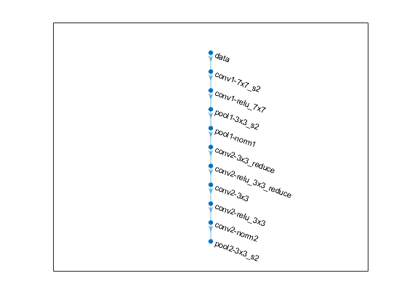

tempLayers = [

convolution2dLayer([1 1],96,"Name","inception_3a-3x3_reduce","BiasLearnRateFactor",2)

reluLayer("Name","inception_3a-relu_3x3_reduce")

convolution2dLayer([3 3],128,"Name","inception_3a-3x3","BiasLearnRateFactor",2,"Padding",[1 1 1 1])

reluLayer("Name","inception_3a-relu_3x3")];

lgraph = addLayers(lgraph,tempLayers);

tempLayers = [

convolution2dLayer([1 1],64,"Name","inception_3a-1x1","BiasLearnRateFactor",2)

reluLayer("Name","inception_3a-relu_1x1")];

lgraph = addLayers(lgraph,tempLayers);

tempLayers = [

maxPooling2dLayer([3 3],"Name","inception_3a-pool","Padding",[1 1 1 1])

convolution2dLayer([1 1],32,"Name","inception_3a-pool_proj","BiasLearnRateFactor",2)

reluLayer("Name","inception_3a-relu_pool_proj")];

lgraph = addLayers(lgraph,tempLayers);

tempLayers = [

convolution2dLayer([1 1],16,"Name","inception_3a-5x5_reduce","BiasLearnRateFactor",2)

reluLayer("Name","inception_3a-relu_5x5_reduce")

convolution2dLayer([5 5],32,"Name","inception_3a-5x5","BiasLearnRateFactor",2,"Padding",[2 2 2 2])

reluLayer("Name","inception_3a-relu_5x5")];

lgraph = addLayers(lgraph,tempLayers);

tempLayers = depthConcatenationLayer(4,"Name","inception_3a-output");

lgraph = addLayers(lgraph,tempLayers);

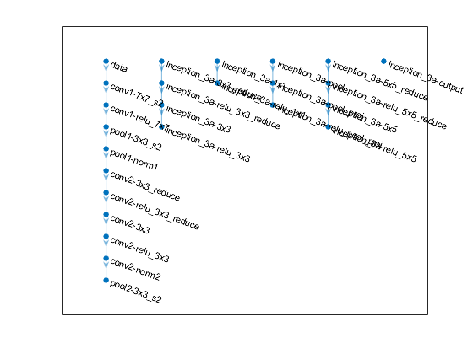

lgraph = connectLayers(lgraph,"pool2-3x3_s2","inception_3a-3x3_reduce");

lgraph = connectLayers(lgraph,"pool2-3x3_s2","inception_3a-1x1");

lgraph = connectLayers(lgraph,"pool2-3x3_s2","inception_3a-pool");

lgraph = connectLayers(lgraph,"pool2-3x3_s2","inception_3a-5x5_reduce");

lgraph = connectLayers(lgraph,"inception_3a-relu_1x1","inception_3a-output/in1");

lgraph = connectLayers(lgraph,"inception_3a-relu_3x3","inception_3a-output/in2");

lgraph = connectLayers(lgraph,"inception_3a-relu_pool_proj","inception_3a-output/in4");

lgraph = connectLayers(lgraph,"inception_3a-relu_5x5","inception_3a-output/in3");

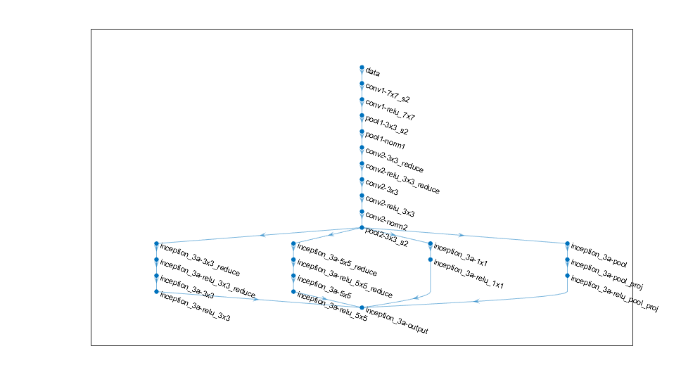

tempLayers = [

convolution2dLayer([1 1],32,"Name","inception_3b-5x5_reduce","BiasLearnRateFactor",2)

reluLayer("Name","inception_3b-relu_5x5_reduce")

convolution2dLayer([5 5],96,"Name","inception_3b-5x5","BiasLearnRateFactor",2,"Padding",[2 2 2 2])

reluLayer("Name","inception_3b-relu_5x5")];

lgraph = addLayers(lgraph,tempLayers);

tempLayers = [

maxPooling2dLayer([3 3],"Name","inception_3b-pool","Padding",[1 1 1 1])

convolution2dLayer([1 1],64,"Name","inception_3b-pool_proj","BiasLearnRateFactor",2)

reluLayer("Name","inception_3b-relu_pool_proj")];

lgraph = addLayers(lgraph,tempLayers);

tempLayers = [

convolution2dLayer([1 1],128,"Name","inception_3b-1x1","BiasLearnRateFactor",2)

reluLayer("Name","inception_3b-relu_1x1")];

lgraph = addLayers(lgraph,tempLayers);

tempLayers = [

convolution2dLayer([1 1],128,"Name","inception_3b-3x3_reduce","BiasLearnRateFactor",2)

reluLayer("Name","inception_3b-relu_3x3_reduce")

convolution2dLayer([3 3],192,"Name","inception_3b-3x3","BiasLearnRateFactor",2,"Padding",[1 1 1 1])

reluLayer("Name","inception_3b-relu_3x3")];

lgraph = addLayers(lgraph,tempLayers);

tempLayers = [

depthConcatenationLayer(4,"Name","inception_3b-output")

maxPooling2dLayer([3 3],"Name","pool3-3x3_s2","Padding",[0 1 0 1],"Stride",[2 2])];

lgraph = addLayers(lgraph,tempLayers);

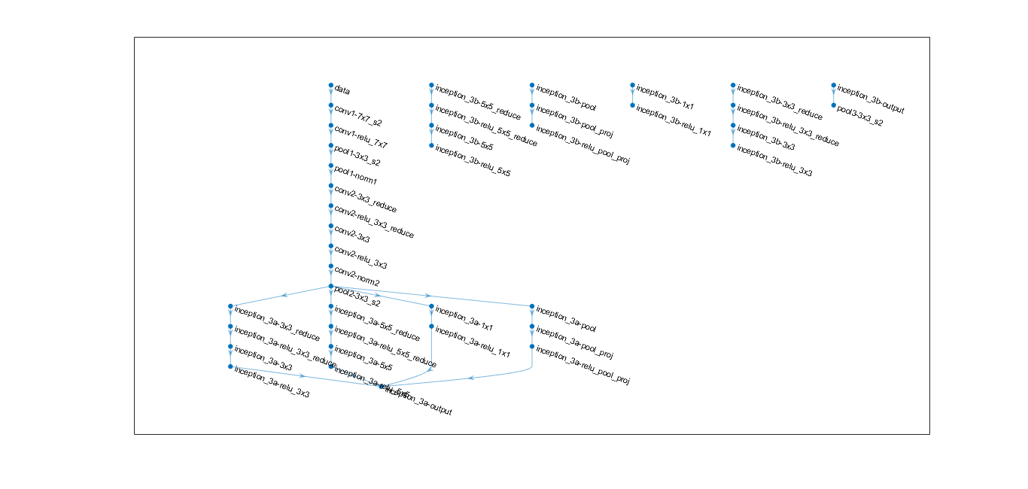

lgraph = connectLayers(lgraph,"inception_3a-output","inception_3b-5x5_reduce");

lgraph = connectLayers(lgraph,"inception_3a-output","inception_3b-pool");

lgraph = connectLayers(lgraph,"inception_3a-output","inception_3b-1x1");

lgraph = connectLayers(lgraph,"inception_3a-output","inception_3b-3x3_reduce");

lgraph = connectLayers(lgraph,"inception_3b-relu_pool_proj","inception_3b-output/in4");

lgraph = connectLayers(lgraph,"inception_3b-relu_5x5","inception_3b-output/in3");

lgraph = connectLayers(lgraph,"inception_3b-relu_1x1","inception_3b-output/in1");

lgraph = connectLayers(lgraph,"inception_3b-relu_3x3","inception_3b-output/in2");

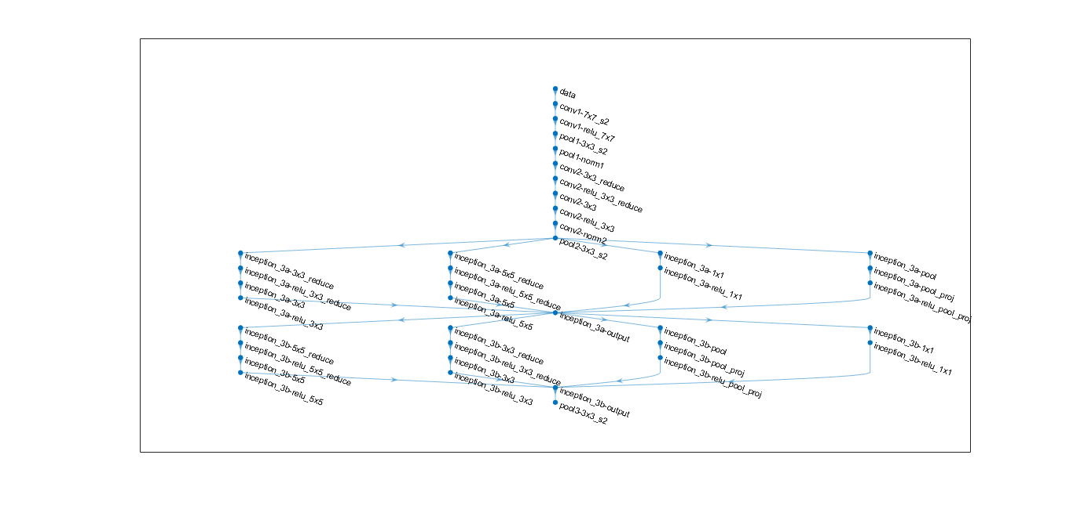

Output layers

tempLayers = [

depthConcatenationLayer(4,"Name","inception_5b-output")

globalAveragePooling2dLayer("Name","pool5-7x7_s1")

dropoutLayer(0.4,"Name","pool5-drop_7x7_s1")

fullyConnectedLayer(1000,"Name","loss3-classifier","BiasLearnRateFactor",2)

softmaxLayer("Name","prob")

classificationLayer("Name","output")];

lgraph = addLayers(lgraph,tempLayers);

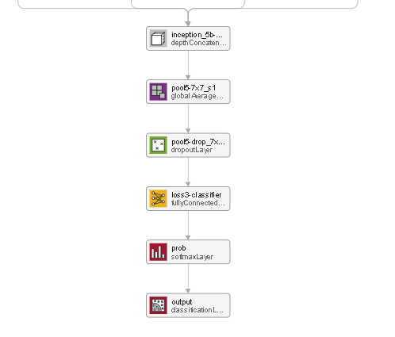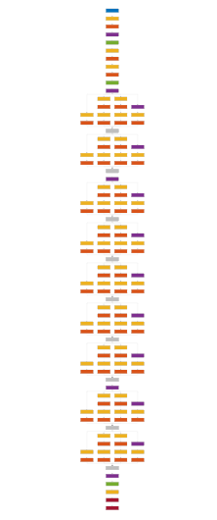

3b

3a

5b

4d

4e

5a

4c

4b

4a